**Activity 3:**

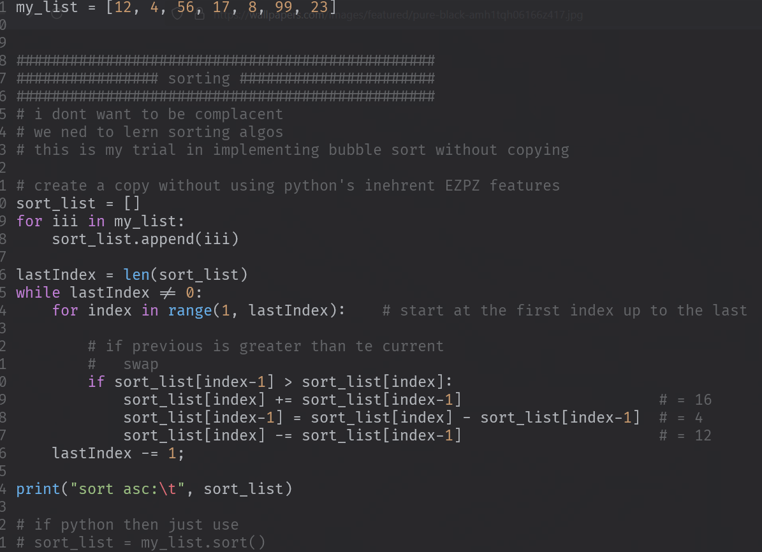

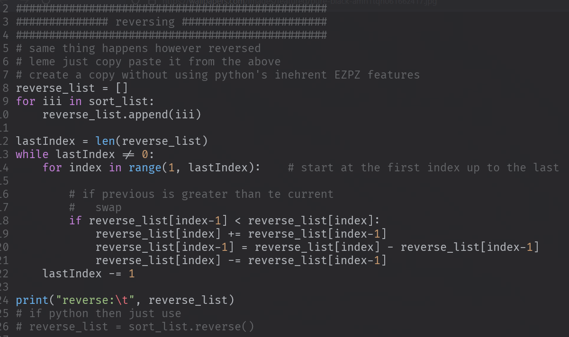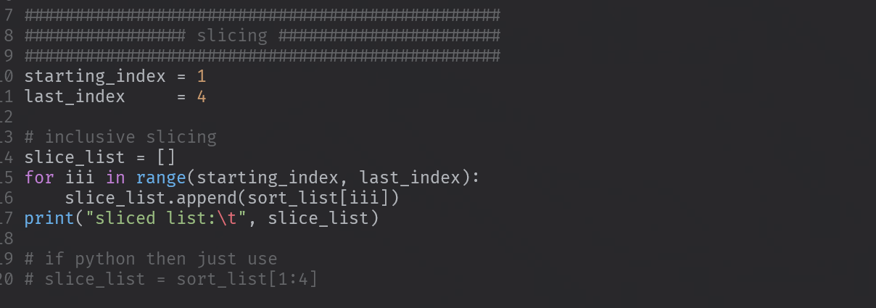

**OUTPUT:**

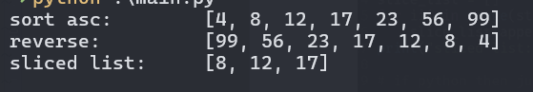

**Activity 4**

letters = ['a', 'b', 'c', 'd', 'e', 'f']  
  
  
def insert_letter(listlist, letter=None, index=0):  
 # i dont wnat to use the insert built-in function  
 # concept:  
 # 1. divide the array (1 copy left half and 1 copy to the right half)  
 # 2. then insert whatatevber to the left of half at the last elemnet  
 # 3. return the (join the left half and right half)  
  
 # create a copy of the left half and right half  
 # hehe tinatamad na me  
 leftHalf = listlist[0:index]  
 rightHalf = listlist[index:] # 1  
  
 leftHalf.append(letter) # 2  
  
 leftHalf.extend(rightHalf) # 3  
 return leftHalf  
  
  
testinsert = insert_letter(letters, "zz", 4)  
print(testinsert)  
  
def remove_letter(listlist, letter):  
 # concept  
 # have an another list  
 # just loop through the listlist and dont include letter to the another list  
 tempCache = []  
 for iii in listlist:  
 if iii == letter:  
 continue  
 tempCache.append(iii)  
 return tempCache  
  
  
testremove = remove_letter(letters, 'd')  
print(testremove)  
  
  
def search_letter(listlist, letter = None):  
 for iii in range(len(listlist)):  
 if letter == listlist[iii]:  
 return iii  
 print("not found")  
 return None  
  
testsearch = search_letter(letters, 'a')  
print(testsearch)

**OUTPUT:**

